**AIM:**

**ALGORITHM:**

1. Build a **max heap** from the input array.
2. Swap the root (maximum element) with the last element of the heap.
3. Reduce the heap size by one and **heapify** the root.
4. Repeat steps 2–3 until the heap size becomes 1.
5. The array is now sorted in ascending order.

**CODE:**

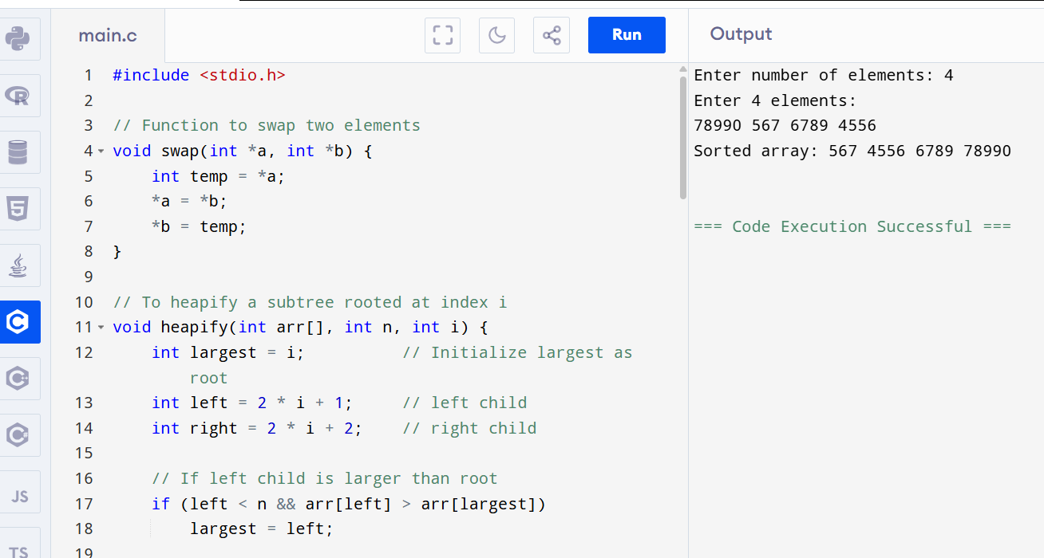

**OUTPUT:**

Enter number of elements: 4

Enter 4 elements:

78990 567 6789 4556

Sorted array: 567 4556 6789 78990